 | IAAF CERTIFICATION SYSTEM  Track and Field Facilities Measurement Report  Outdoor Facilities – Shot Put

This form must be sent to: technicalofficer@iaaf.org

Address: IAAF, Att. Technical Manager, 6-8 Quai Antoine 1er, BP 359, MC 98007 Monaco Cedex

FACILITY
Name of Facility / Stadium:
Address:
City:
Country:
Telephone:
Fax:

Owner of Facility / Stadium:

Address:

E-mail:

SURVEY WORK
Surveyor Company:
Surveyor’s Name:
Qualifications:
Address:
Telephone:
Fax:
E-mail:
Date(s) of Survey: |  | Temperature:
Weather:

Instruments*: | Theodolite: |  | No.:
Instruments*: | Distance Meter: |  | No.:
*Certificates of instrument accuracy shall be attached.
General:
Requirements are indicated. (See also “Commentary” on page 24!)
Test methods are explained.

Distances longer than 20m are to be measured by electro optical instruments.
Angles are to be measured by theodolite.

Facility for the Shot Put

 | IAAF Rule Requirement |  |  | Circle A | Circle B | Circle C
The Shot circle | The material of the circle is in accordance with the Rule. |  |  | Y N | Y N | Y N
The Shot circle | The top of the circle is flush with the ground outside. (Rule 187.5) |  |  | Y N | Y N | Y N
The Shot circle | White lines are drawn from the top of the metal rim. The construction is in accordance with the Rule.  min. 0.75m long, 50mm wide  (Rule 187.7) |  |  | Y N | Y N | Y N
The Shot circle | The interior of the circle is constructed of:
The Shot circle | The surface is level and lower than the upper edge of the rim of the circle. |  |  | Y N | Y N | Y N
The Shot circle | The rim is min. 6 mm thick and painted white. |  |  | Y N | Y N | Y N
The Shot circle | The circle has an inside diameter of:  min. 2.130m  max. 2.140m  (IAAF Rule 187.6)  The circle has a depth of:  min. 14mm  max. 26mm  (Rule 187.5) | D1 | Diameter | m | m | m
The Shot circle |  | D1 | Circle depth | mm | mm | mm
The Shot circle |  | D1 | Circle depth | mm | mm | mm
The Shot circle |  | D2 | Diameter | m | m | m
The Shot circle |  | D2 | Circle depth | mm | mm | mm
The Shot circle |  | D2 | Circle depth | mm | mm | mm
The Shot circle |  | D3 | Diameter | m | m | m
The Shot circle |  | D3 | Circle depth | mm | mm | mm
The Shot circle |  | D3 | Circle depth | mm | mm | mm
The Shot circle |  | D4 | Diameter | m | m | m
The Shot circle |  | D4 | Circle depth | mm | mm | mm
The Shot circle |  | D4 | Circle depth | mm | mm | mm
The Shot circle |  | Circle depth at centre |  | mm | mm | mm

The stop board must be checked before a competition.

 | IAAF Rule Requirement | Circle A | Circle B | Circle C
The landing sector | The landing sector consist of:  (Rule 187.10)
The landing sector | The maximum overall downward inclination of the landing sector in the putting direction does not exceed 1:1000. (Rule 187.11) | Y N | Y N | Y N
Note: Provide levels at the circles and for the landing areas at the 10m, 15m, 20m and 25m arcs at the two sector extremities and the centreline. Use a separate drawing for providing the required spot levels.

Attachments
(Check mark the appropriate box below for each attachment provided with this report.)

Certificates of instrument accuracy.

Plan showing field event layouts relative to the tracks (layout drawing).

Photographs showing the method of construction.

Levels at the Shot Put circles and for the landing areas at the 10m, 15m, 20m and 25m arcs at the two sector extremities and the centreline.

Conclusions

The competition area was checked regarding layout, gradient and dimensional accuracy.

I hereby certify that all measurements and information shown in this report are accurate and are the result of a well-conducted survey.
Considering the attached measurements made during the inspection of the facility, I recommend that the facility be granted a confirmation of compliance with IAAF requirements.

YES NO

If the answer is NO please state below the reason(s) why the facility does not come under the IAAF Rules.

Date:
Surveyor’s Name:
Signature:

Outdoor Facilities Measurement Report Commentary

Introduction

All the information required in this proforma must be determined by the surveyor and he should not rely on any other measurement work that may have been done by others.

It is not for the surveyor or others to determine whether dispensations might be provided for any non-conformity with the IAAF Rules or the recommendations of the IAAF Track and Field Facilities Manual. These are matters for the IAAF alone to determine.

For ease of distribution of the report it is recommended that the report be in Word document or Adobe pdf format. It is also preferred that the measurements be typed onto the form. If for some reason that is not possible then the figures should be written clearly in black ink.

If there are more facilities than allowed for on the proforma, the same information as that requested should be provided for the extra facilities.

All measurements/calculations of length must be to the nearest mm. No negative tolerances are allowed in the measured distance of races.

Page 1 Instruments

The surveyor must provide a current Certificate of Instrument Accuracy that can be traced back to national and international standards of measurement.

Spot levels

Use separate drawings for providing the required spot levels.

It is essential that reduced levels not grades be provided on each of the runways at the intervals as requested on the proforma including the take-off board and at the planter box as appropriate.

Throwing sector landing areas: spot levels on each of them should be taken at the arcs indicated at the two sector extremities and the centreline. The inclination indicated on the proforma should be the one that gives the greatest downward inclination or the least upward inclination at the particular arc. The inclinations are not to be averaged.

The sign convention used by the IAAF for inclinations is that an upward inclination in the direction of running or throwing is positive. At any radius, the lowest level is compared with the throwing circle/runway level to determine the inclination.

Levels – Shot Put
(Copy if there are more sites)

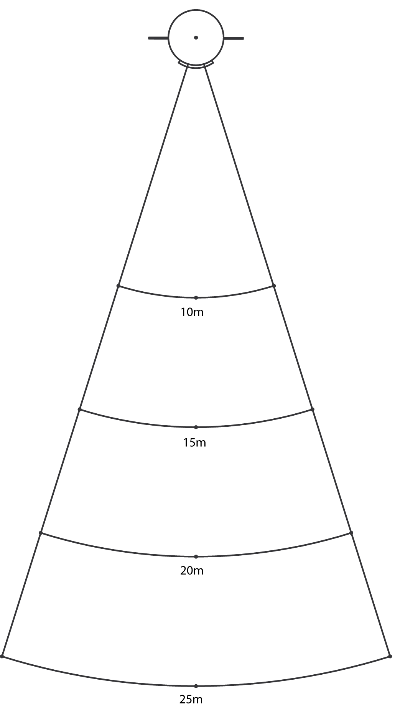

Name and City of Facility:
Site identification:

